**Java String indexOf() Method with example**

BY CHAITANYA SINGH | FILED UNDER: [STRING HANDLING](https://beginnersbook.com/category/string-handling/)

**Java String indexOf() method** is used to find the index of a specified character or a substring in a given String. There are 4 variations of this method in [String class](https://beginnersbook.com/2013/12/java-strings/):

**The indexOf() method signature**

int indexOf(int ch): It returns the index of the first occurrence of character ch in a given String.

int indexOf(int ch, int fromIndex): It returns the index of first occurrence of character ch in the given string after the specified index “fromIndex”. For example, if the indexOf() method is called like this str.indexOf(‘A’, 20) then it would start looking for the character ‘A’ in string str after the index 20.

int indexOf(String str): Returns the index of string str in a particular String.

int indexOf(String str, int fromIndex): Returns the index of string str in the given string after the specified index “fromIndex”.

All the above variations **returns -1** if the specified char/substring is not found in the particular String.

**Java String indexOf() Method example**

public class IndexOfExample{

public static void main(String args[]) {

String str1 = new String("This is a BeginnersBook tutorial");

String str2 = new String("Beginners");

String str3 = new String("Book");

String str4 = new String("Books");

System.out.println("Index of B in str1: "+str1.indexOf('B'));

System.out.println("Index of B in str1 after 15th char:"+str1.indexOf('B', 15));

System.out.println("Index of B in str1 after 30th char:"+str1.indexOf('B', 30));

System.out.println("Index of string str2 in str1:"+str1.indexOf(str2));

System.out.println("Index of str2 after 15th char"+str1.indexOf(str2, 15));

System.out.println("Index of string str3:"+str1.indexOf(str3));

System.out.println("Index of string str4"+str1.indexOf(str4));

System.out.println("Index of hardcoded string:"+str1.indexOf("is"));

System.out.println("Index of hardcoded string after 4th char:"+str1.indexOf("is", 4));

}

}

**Output:**

Index of B in str1: 10

Index of B in str1 after 15th char:19

Index of B in str1 after 30th char:-1

Index of string str2 in str1:10

Index of str2 after 15th char-1

Index of string str3:19

Index of string str4-1

Index of hardcoded string:2

Index of hardcoded string after 4th char:5

**Another example of indexOf() method**

Lets take a simple example with a short string where we are finding the indexes of given chars and [substring](https://beginnersbook.com/2013/12/java-string-substring-method-example/) using the indexOf() method.

public class JavaExample {

public static void main(String[] args) {

String str = "Java String";

char ch = 'J';

char ch2 = 'S';

String subStr = "tri";

int posOfJ = str.indexOf(ch);

int posOfS = str.indexOf(ch2);

int posOfSubstr = str.indexOf(subStr);

System.out.println(posOfJ);

System.out.println(posOfS);

System.out.println(posOfSubstr);

}

}

# Java: Finding the Nth occurrence of a substring in a String

public static int ordinalIndexOf([String](https://docs.oracle.com/javase/8/docs/api/java/lang/String.html) str, [String](https://docs.oracle.com/javase/8/docs/api/java/lang/String.html) substr, int n) {

int pos = -1;

do {

pos = str.[indexOf](https://docs.oracle.com/javase/8/docs/api/java/lang/String.html#indexOf-java.lang.String-int-)(substr, pos + 1);

} while (n-- > 0 && pos != -1);

return pos;

}

ordinalIndexOf(s, ss, 0) is equivalent to s.indexOf(ss)

ordinalIndexOf(s, ss, 1) is equivalent to s.indexOf(ss, s.indexOf(ss) + 1)

and so on...

**Output:**  
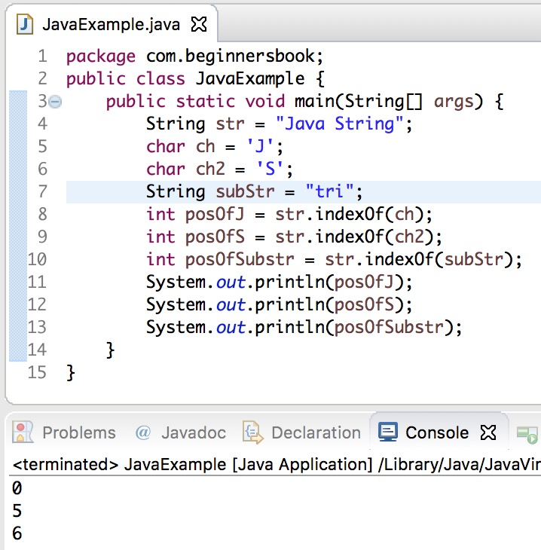

[❮ P](https://beginnersbook.com/2013/12/java-string-endswith-method-example/)

## Get the index of the nth occurrence of a substring in a String using Java?

To find the index of nth occurrence of a substring in a string you can use String.indexOf() function.

A string, say str2, can occur in another string, say str1, n number of times. There could be a requirement in your Java application, that you have to find the position of the nth occurrence of str2 in str1. Be it first occurrence, second or some fifth occurrence.

In this tutorial, we shall learn to get the index of nth occurrence of a string in another string using Java. We shall look into examples, where we consider the case and not consider the case of alphabets in the strings.

We shall make use of String.indexOf(String otherString) method, and a for loop to find the index of nth occurrence of string str2 in str1.

### Example – Get the index of nth occurrence of a substring

In this example, we shall initialize two strings with variable names str1 and str2. And we are going to find the second occurrence of str2 in str1. You can change the value of n and observe the result.

NthOccuranceExample.java

|  |
| --- |
| /**  * An example java program to get the index of nth occurrence of a substring in a String using Java  */  public class NthOccuranceExample {        public static void main(String[] args) {          String str1 = "helloworld good morning good evening good night";          String str2 = "ing";          int n = 2;            int index = nthOccurrence(str1, str2, n);          System.out.println("index of str2 in str1 at occurrence "+ n +" = "+ index);      }        public static int nthOccurrence(String str1, String str2, int n) {            String tempStr = str1;          int tempIndex = -1;          int finalIndex = 0;          for(int occurrence = 0; occurrence < n ; ++occurrence){              tempIndex = tempStr.indexOf(str2);              if(tempIndex==-1){                  finalIndex = 0;                  break;              }              tempStr = tempStr.substring(++tempIndex);              finalIndex+=tempIndex;          }          return --finalIndex;      }  } |

When the above program is run, the output to the console is as shown below.

Console Output

|  |
| --- |
| index of str2 in str1 at occurrence 2 = 33 |

### Example – Get the index of nth occurrence of a substring – Ignore Case

In this example, we ignore the case of both the strings and try to find the second occurrence of string str2 in string str1. To ignore the case, we have actually converted the strings to lowercase.

Nore that for the function, nthOccurrence(), we have added a forth argument deciding whether to consider or not consider the case.

FirstOccuranceExample

|  |
| --- |
| /**  * An example java program to get the index of nth occurrence of a substring in a String using Java  */  public class NthOccuranceExample {        public static void main(String[] args) {          String str1 = "helloworld good morning good evening good night";          String str2 = "GOOD";          int n = 2;            int index = nthOccurrence(str1, str2, n, true);          System.out.println("index of str2 in str1 at occurrence "+ n +" = "+ index);      }        public static int nthOccurrence(String str1, String str2, int n, boolean ignoreCase) {          if(ignoreCase) {              str1 = str1.toLowerCase();              str2 = str2.toLowerCase();          }            String tempStr = str1;          int tempIndex = -1;          int finalIndex = 0;          for(int occurrence = 0; occurrence < n ; ++occurrence){              tempIndex = tempStr.indexOf(str2);              if(tempIndex==-1){                  finalIndex = 0;                  break;              }              tempStr = tempStr.substring(++tempIndex);              finalIndex+=tempIndex;          }          return --finalIndex;      }  } |

Run the program.

Console Output

|  |
| --- |
| index of str2 in str1 at occurrence 2 = 24 |

### Conclusion

In this [Java Tutorial](https://www.tutorialkart.com/java-tutorials/), we have learned how to get index of nth occurrence of a substring in a String, by considering or ignoring the case of alphabets.